**Introduction**

WDG-V PC configurator tool (here after referred to as “the WDG-V configurator”) is a tool used to configure the WDG-V sensor. The application allows the user to configure, calibrate and run diagnostics on the sensor. The application communicates with the sensor through MODBUS RTU protocol on RS-485 interface. The parameter map for the sensor is already defined and the same is present in the appendix.

This document lists the requirements for the implementation of the WDG-V configurator. The requirements are grouped according to the screens.

**Requirements**

**General**

* The WDG-V configurator should be able to communicate with the sensor board over MODBUS RTU protocol.
* The WDG-V configurator should be able to run on Windows XP, Windows 8
* The WDG-V configurator should install without requiring any administrator access.
* the WDG-V configurator installer should install all the required libraries or inform the user of the resources not available with a suitable message
* The WDG-V configurator installer should create a desktop shortcut and a shortcut in the program menu.
* On start-up of the WDG-V configurator, user should be able to select the address of the sensor and the serial port on which to connect.
* The Baud rate of the communication should be fixed to 57600bps.
* The WDG-V configurator should be able to provide a suitable error message if it is not able to communicate on the provided serial port.
* The WDG-V configurator should be able to provide a suitable error message if it is not able to communicate with the sensor on the provided address.

**Main display/Home page**

* The main page of the WDG-V configurator should display the following:
* Oxygen concentration
* Concentration of the other configured gases (Methane, Combustibles)
* Alarms : **parameter 177 and parameter 178**
* Current status of the sensor : **parameter 108**
* On time : **parameter 130**
* Total on time : **parameter 131**
* Electric temp : **parameter 9**
* Cell temp : **parameter 5**
* Box temp : **parameter 6**
* Flow percentage (if configured) : **parameter 216**
* Cell millivolts : **parameter 7**
* The main page layout should be as given below:

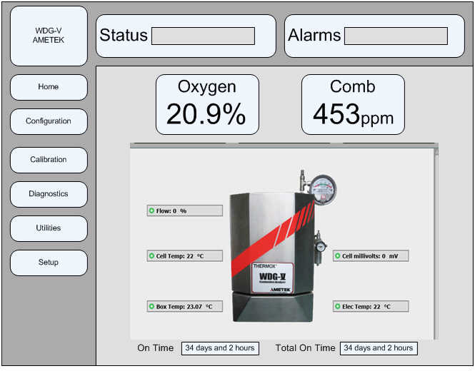

* The data on screen should be updated every 2 seconds.
* The concentration of the gases should be displayed prominently with the correct units.
* The WDG-V configurator displays the Oxygen concentration by default. The other gases; Methane and Combustibles; are displayed if they are configured in the sensor. The data is present in the **parameter 41**. The bits set provide the configuration details as follows:
* **0x0001: Combustible sensor present**. Display the combustibles concentration in main display if this bit set.
* **0x0002: Methane sensor present**. Display the methane concentration in main display if this bit set.
* 0x0004: Auto calibration enabled.
* **0x0008: Flow sensor present**. Display the flow value on the main display if this bit set.
* The concentration values are stored in the following parameters
* Oxygen : **parameter 1**
* Combustibles : **parameter 2**
* Methane : **parameter 3**
* The units for the gases are as follows:
* Oxygen : **%**
* Combustibles : **ppm**
* Methane : **%**
* The alarms are set according to the bit values. The alarms generated are as given below:

(**Parameter 177 bit 0**) => "Cell T/C Failure",

"Cold Junction Compensator Failure",

"Cell Temperature Control",

"Cell Over Temp",

"Cell Under Temp",

"Cell Temp Rise failure",

"Over Temp Relay tripped",

"RTD Failure",

"Box Temp High",

"Box Temp Low",

"Box Temp Rise Failure",

"Low Sample Flow",

"Cell Failure (open)",

"Combustible Detector Open",

"Methane Detector Open",

"Cell Mv Mismatch",

"Analog Output 1 Error",

"Flow Sensor Failure",

"T/C Mismatch",

"Cell life nearing its end",

"Cmb Detector life nearing its end",

"CH4 Detector life nearing its end",

"High Cell Mv",

"Analog Output1 out of range",

"Analog Output2 out of range",

"Analog Output3 out of range",

"Last O2 Span Calibration Failed",

"Last O2 Zero Calibration Failed",

"Last Comb Calibration Failed",

"Last CH4 Calibration Failed",

"Last Flow Calibration failed",

"Oxygen Calibration Required",

(**Parameter 178 bit 0**) => "Comb Calibration Required",

"CH4 Calibration Required",

"Flow Sensor Calibration Required",

"Oxygen Hi",

"Oxygen Lo",

"Combustibles Hi",

"Combustibles Lo",

"Methane Hi",

"Methane Lo",

"Cell Mv Hi"

* There can be multiple alarms for the same sensor and all the alarms should be scrolled/displayed one after the other.
* The box displaying alarms should turn red in case there is an alarm. The default string should be "None".
* Alarm bar should be **RED** when alarms exist and **YELLOW** when warnings exist. To distinguish between a warning and an alarm, please look into Configurator Notes Ver 2 - 6-18-2013 doc in client provided.
* The bottom bar color should show the worst case status, that is if both alarms and warnings are present, the bottom bar should be RED. The process alarm must have no color
* When the alarm is oxy hi/lo, comb hi/lo or meth hi/lo there should be an up or down arrow; corresponding with the error; that should be displayed along with the concentration values.
* The app should be able to provide a separate alarm when the communication with the sensor is lost. The app should continue to try to connect to the sensor.
* The status is set according to the value in the **parameter 108**. The values and the corresponding strings are as provided:

0: "Startup"

1: "Warm-up"

2: "Normal"

3: "Diagnostics"

4: "Calibration"

5: "Cal Recovery"

6: "FAIL"

* The status box back ground should become **red** if the status is "**FAIL**". The default string should be "**Startup**".
* The temperature values (cell, box and electric) are float and should display 1 decimal point with unit as degree C.
* The time values are stored in the sensor in terms of hours. These need to be changed to days and hours and displayed.
* The flow value is displayed if the sensor is configured. The value is a displayed as an integer with unit as "%".

**[TISMO: Changes from Ametek 5July2013]**

* The values are updated once the user enters a particular screen (config, calib, etc), but not when the user enters a particular tab. It does not reflect the correct values especially if the value has changed by other means, This is especially visible in date and time set functionality.

**[TISMO:Changes from Ametek 17 Sept 2013]**

* Add the sensor name on the home screen immediately below or above the picture of the analyzer.  If the name is blank on the analyzer then it should default to "WDGV-n" where 'n' is the address of the analyzer.   Again if this adds considerable time/complexity it is not a high priority item

**Configuration**

* The data for all the parameters should be got from the sensor at the moment of entering the screen. No need for polling in this screen.
* The WDG-V configurator should allow the user the view and modify the sensor configuration. The options to be as given below:
* Combustibles
* Methane
* Auto-Calibration
* Flow

The parameter to be used is 41. The user should be able to select or deselect the options. The bits to be set are as given below.

* **0x0001: Combustible sensor enable/disable**.
* **0x0002: Methane sensor enable/disable**.
* **0x0004: Auto calibration enable/disable**.
* **0x0008: Flow sensor enable/disable.**
* The WDG-V configurator should allow the user to configure the analog outputs. There should be 3 analog outputs supported and all three should support the following:
* Function: Oxygen (0)/Cell mV (3)/Methane (2)/Combustibles (1) (depending upon the sensor configuration)
* Mode: 0-20ma (0)/4-20ma (1)/Nemur (2).
* Span value: Float value.
* Zero Value Float value.
* Track/Hold during Cal: Track during Cal/Hold during Cal

The parameters that are used to get and set are as follows:

|  |  |  |  |  |  |
| --- | --- | --- | --- | --- | --- |
|  | Function | Mode | Span | Zero | Track/Hold |
| Analog output 1 | 51 | 50 | 52 | 53 | 49 |
| Analog output 2 | 57 | 56 | 58 | 59 | 55 |
| Analog output 3 | 63 | 62 | 64 | 65 | 61 |

* The WDG-V configurator should allow the user to view and modify the sensor name. The Sensor name is a string (max 10 chars) which is stored in **parameter 186**. The string should always end with the NULL (/0) character.
* The WDG-V configurator should allow the user to view and modify the Process pressure. The corresponding value is stored in **parameter** **185.**
* The WDG-V configurator should allow the user to view and modify the time in the sensor. The time is stored as an integer which is in Epoch time (number of seconds from 1 1 1970). The read and write parameters are different. The value should be **read** from **parameter 169** and the value is written in **parameter 170**. The display format is ***hh:mm:ss***.
* The WDG-V configurator should allow the user to configure the alarms onto the 3 relays. The alarm configuration should support the following fields:
* Function: Drop box allowing the user to select the gases (oxygen, methane and combustibles depending upon the configuration) or to disable the alarm. The valid values are Disabled/Oxygen/Combustibles/Methane (depending upon configuration)
* Hi Limit: A number filed taking float values which determines the max limit for the function. Should display 2 decimal fields.
* Lo Limit: A number filed taking float values which determines the min limit for the function. Should display 2 decimal fields
* Energize on Alarm: An option to switch on the alarm.

The parameters for the three alarms are as follows

|  |  |  |  |  |
| --- | --- | --- | --- | --- |
|  | Function | Hi limit | Lo limit | Energize on Alarm |
| Relay 3 | 150 | 151 | 152 | 153 |
| Relay 4 | 154 | 155 | 156 | 157 |
| Relay 5 | 158 | 159 | 160 | 161 |

* All the “***Accept***” buttons on the screen should provide a message on pressing to provide the user with information that the message was sent to the sensor.  
    
  **[TISMO: Changes from Ametek]**
* "Configuration ->Process Pressure" screen : There is no parameter associated with the units. The default unit is kPa. If the user selects PSI, the value should be converted from kPa to PSI and displayed.
* “Configuration -> Process Alarm” screen

Oxygen: Minimum = 0%, Maximum = 100%

Combustibles: Minimum = 0ppm, Maximum = 10000ppm

CH4: Minimum = 0%, Maximum = 5%

* For the ‘Energize on Alarms’ drop down, display ‘Energize’ and ‘Deenergize’ as the options, with ‘Deenergize’ as the default value.
* Use ‘Relay 3’, ‘Relay 4’, ‘Relay 5’ instead of ‘Relay 1’, ‘Relay 2’, ‘Relay 3’
* “Configuration -> Analog outputs” screen

Cell MV: Minimum = -32mv, Maximum = 200mv

**[TISMO: Changes from Ametek-5 July 2013]**

Analog out config -> When the user tries to set the value of one of the analog out values without changing the other two, the app gives an error as the values entered for the other two are not correct even though the values changed is only for one. The app should check for the changed values and set the same. So if the user changes for analog out 1 then only those values should be validated and set. The others should not be validated or set.

**[TISMO:Changes from Ametek 17 Sep 2013]**

* I think I may have given you wrong information about the Sensor Name byte order.  Currently the order is wrong and I believe it is what I told you.  That said, it needs to be changed now as it does not match our Host.  Below is an example of what should be written to the NAME parameters given a desired name of "123456".   Basically the bytes for each parameter are currently reversed.   So sorry for the inconvenience.

NAME1 =>  0x3231  
        NAME2 =>  0x3433  
        NAME3 =>  0x3635

**Calibration**

* The WDG-V configurator should support the following types of calibrations:
* Manual
* Remote
* Auto

The procedure for the calibration and the screens for the same are detailed in the document: Calibration Requirement-Ver 0.1.docx

* The WDG-V configurator should allow the user to view the calibration history. The sensor stores the last ten calibration data and time. These are to be displayed in a table and a graph (with time on x-axis and values on y-axis). The data is stored in parameters as follows:
* O2 History – value (parameters 68-77) (2 decimal places)
* O2 History – time (parameters 78-87) (N/A)
* Comb History – value (parameters 88-97) (0 decimal places)
* Comb History1 – time (parameters 98-107) (N/A)
* CH4 History1 – Value (parameters 191-200) (2 decimal places)
* CH4 History1 – time (parameters 201-210) (N/A)

If values are zero then they are blank and should not be shown

* The WDG-V configurator should allow the user to view and modify the Auto-Calibration configuration values. Following are the fields the user should be able to configure:
* Calibration Gas Duration: This field allows the user to input the duration of calibration in Minutes (**parameter 38**)
* Calibration Frequency: This field allows the user to set the frequency of calibration in days (**parameter 163**)
* Calibration Start Time: The filed sets the start time of the calibration. The time is stored as an EPOCH time(**parameter 164**)
* Calibration Start Date: The filed sets the start date of the calibration. The date is stored as an EPOCH date(**parameter 164**)
* Auto calibration Enable: This allows the user to enable/disable Auto calibration.(**parameter 162**)
* Next Calibration on (EPOCH) this is a read only value (**parameter 171**) to be displayed so the user will know exactly when the next calibration is after configuring the auto calibration parameters.

**[TISMO: Changes from Ametek-9 July 2013]**

* When the command parameter (42) is to be written during a calibration, it must be the last parameter sent when multiple parameters are written. This will prevent the calibration from starting on the analyzer before the other data is written (i.e. gas durations, etc).
* *Manual Calibration* – When doing a combustible only or methane only cal, the Oxygen value is displayed during the zero cal and the Oxygen zero drift value is displayed in the results. Additionally the Oxygen Zero Cal gas value is enabled and can be set even though we are not doing an Oxygen Cal.
* *Manual Calibration:* Increase the size of the text for the command messages during manual and remote cal sequences. (i.e. “Inject O2 Span Gas”, “Inject Zero Gas”, etc) These should be larger and be obvious that they are instructions for the user.
* *Cal Gas Values* – Not sure if this made it into the requirements, but there needs to be the ability to set the cal gas values without starting a calibration. There should be an additional tab under Calibration for doing this. The tab text should be “Cal Gas Values” and the screen should allow the user to set the O2 Span, O2 Zero, Comb Span, and Methane span gas values. As with the other screens, the combustible and methane gas values should only be accessible if the option is enabled. This screen is necessary because of the ability to trigger cals from the real time clock.The Cal gas duration field is NOT required as it is in the Auto Cal Config tab.
* Calibration result : After the analyzer calibrates it may take a second or two to crunch the numbers and update the status. That said the status bits may not have been updated yet when you read them. I suggest waiting 3 seconds before checking the status. On our Host interface we display a pop-up window informing the user the calibration is being calculated while we wait. We can probably do something similar here. Result according to parameter 149.
* When doing a remote cal, please change the “Inject xxxx xxx Gas” text to “Injecting xxxx xxx Gas”. This is because the gases are switched automatically in a remote cal when the previous gas is ‘Accepted’. Leaving the verbiage as ‘Inject’ implies the user has to do something as is the case in a manual calibration.
* During an auto calibration zero, only one Cal Gas Time item is necessary as it applies to all gases.

**[TISMO:Changes from Ametek on 17 Sept 2013]**

Make the line in the Calibration History plots thicker for easier distinction against the grid lines

**Diagnostic**

* All the data to be displayed in the diagnostic screens are to be updated every 2 seconds.
* The WDG-V configurator should allow the user to view the **Analyser diagnostic** values. These are read only fields which fetch the data from the sensor. The following are the fields to be present:
* Cell Heater Duty Cycle (**parameter** **15**) (2 decimal places)
* Box Heater Duty Cycle (**parameter** **16**) (2 decimal places)
* SIL Temperature (**parameter 122**) (1 decimal place)
* Cell T/C millivolts (**parameter 7**) (2 decimal places)
* RTD Resistance (**parameter 10**) (2 decimal places)
* Analog Output measured (**parameter 121**) (2 decimal places)
* Flow raw counts (**parameter 121**)
* The WDG-V configurator should allow the user to view the **Cell diagnostic** values. These are read only fields which fetch the data from the sensor. The following are the fields to be present:
* Age in days (**parameter 132**)
* Estimated Cell Life in days – display in months by dividing by 30. (**parameter 168**)
* AT Value (**parameter 29**) (2 decimal places)
* Cell Resistance in ohms (**parameter 181**) (2 decimal places)
* Calculated cell temperature in degrees C (**parameter 180**) (1 decimal place)
* Cell millivolts (**parameter 7**) (2 decimal places)
* The WDG-V configurator should allow the user to view the **Combustible detector** **diagnostic** values. These are read only fields which fetch the data from the sensor. The following are the fields to be present:
* Age in days (**parameter 133**)
* Estimated Detector Life in days – display in months by dividing by 30. (**parameter 184**)
* Sensitivity Value (**parameter 33**) (1 decimal place)
* Active element voltage (**parameter 11**) (4 decimal places)
* Reference element voltage (**parameter 12**) (4 decimal places)
* The WDG-V configurator should allow the user to view the **Methane detector** **diagnostic** values. These are read only fields which fetch the data from the sensor. The following are the fields to be present:
* Age in days (**parameter 134**)
* Sensitivity Value (**parameter 173**) (1 decimal place)
* Active element voltage (**parameter 13**) (4 decimal places)
* Reference element voltage (**parameter 14**) (4 decimal places)
* Reference element voltage (**parameter 12**) (4 decimal places)
* The WDG-V configurator should allow the user to diagnose the I/O control units (relays, analog outputs and close contact input). It contains the following elements.
* **Relay output**: There are 5 relay outputs that the user can set/reset. The user should also see the current state of the relay. The current state and the drop box to set/reset for a relay should be side by side. The parameters used for read and write are different. Each relay sets a bit in the **parameter 214** and reads the current state from **parameter 67**. The individual bits represent the individual relay values (0: open and 1: Close) (bit0: relay 0 state, etc..,)
* **Analog output**: There are three analog outputs which the user can set and observe. The user should be able to set a float value and similar to the relay the actual value is to be shown in a read only field next to it. The parameter for read and write are as given below:

|  |  |  |
| --- | --- | --- |
|  | Set | Read |
| Analog Out 1 | 211 | 54 |
| Analog Out 2 | 212 | 60 |
| Analog Out 3 | 213 | 66 |

* **Close contact**: This is a read only field which gives the current state of the close contact input. The value to read is **parameter 139.**

Before entering this screen the sensor should be put into diagnostic mode. This is done by writing **data 0x10 into parameter 42 (Diagnostic mode ON)**. Before exiting the screen the sensor should be put out of diagnostic mode. This is done by writing **0x11 into parameter 42 (Diagnostic mode OFF).**

* The WDG-V configurator should allow the user to have the “**Inject gas**” functionality as seen on host display. This allows the user to observe the sensor outputs by injecting a particular gas; which is selected form the menu. The procedure involves two steps/screens and should be done one after the other (similar to a wizard).
* The starting screen should allow the user to select/deselect the following gases:
* Zero Gas
* Oxygen Span Gas
* Combustible span gas (If sensor is enabled; check parameter 41)
* Methane Span gas (If sensor is enabled; check parameter 41)

On selection of a gas and pressing the “**Start**” button it should proceed to the next screen which is also the result screen

* The result screen should have the following displayed:
* Cell mV value (**Parameter 0x07**; units mV)
* Flow percentage (**Parameter 0x216**; if option enabled (check parameter 41). If not display **N/A**)
* Test time duration (free running timer displayed in mm:ss)
* The selected gas concentration value with unit
* Span gas concentration value of the corresponding gas.
* A button to stop the process and return to the gas selection screen.

The parameter values that are to be used are as given below:

|  |  |  |  |
| --- | --- | --- | --- |
|  | Oxygen | Methane | Combustible |
| Concentration | 1 | 3 | 2 |
| Span gas | 44 | 47 | 46 |

* In case of selection of zero gas; all the configured gases concentration should be displayed. The Span gas value should be displayed only with oxygen display but it should be zero gas span value (**Parameter 45**).

Before entering this screen the sensor should be put into diagnostic mode. This is done by writing **data 0x10 into parameter 42 (Diagnostic mode ON)**. Before exiting the screen the sensor should be put out of diagnostic mode. This is done by writing **0x11 into parameter 42 (Diagnostic mode OFF).**

**[TISMO: Changes from Ametek-9 July 2013]**

* Sensor Diagnostics – the unit for the Analog measured should show ‘ma’ for both the actual and set values.

**[TISMO: Changes from Ametek-6 August 2013]**

* There will be two tabs “IO” and “Inject Gas” tabs. IO tab will have Analog Outputs, Relay Outputs and Contact inputs. No ‘solenoid valves’
* Contact inputs – When “start” is clicked, the other screens will be disabled (navigation blocked) until “stop” is clicked.
* “Inject Gas” tab - This screen will be like a wizard. The First screen will display the list of span gases. On “start” the Results screen will be displayed.
* When “start” is clicked, the other screens will be disabled (navigation blocked) until “stop” is clicked.
* In the 2nd screen, on “stop”, it is mentioned that parameter 42 must be set to 118 and then to 117. But it has to be 17(not 117).
* The max and min values for all analog out values will be 0-24ma
* When "aspirator on" is selected, all of the active concentration values should be shown.   Cal gas values are  not necessary and really don't apply in this case so they should NOT be shown.

Diagnostics - “Inject Gas” tab

* For the statement - Before entering this screen the sensor should be put into diagnostic mode. This is done by writing data 0x10 into parameter 42 (Diagnostic mode ON). Before exiting the screen the sensor should be put out of diagnostic mode. This is done by writing 0x11 into parameter 42 (Diagnostic mode OFF).
* Implemetation   
  A. Before entering the gas selection screen - set 0X10 to parameter 42.   
  B. On “Start” button click - value is set to parameter 42 based on the gas selected.  
  C. On “Stop” button click - set 118 to parameter 42, set 17 to parameter 42.    
  D. On re-entering the gas selection screen - set 0X10 to parameter 42.

**[TISMO:Changes/Issues from Ametek 10 Sept 2013]**

* When doing a Combustible only calibration, the "Reading may not be stable" message appears when you press the 'Accept' button even though the status says 'Ready'.  I suspect this is because it is checking the O2 stable flag as well.  When calibrating just combustibles, only the combustible stable flag should be checked
* The transition between calibration screens can be a bit "klunky" (i.e. the status changes after the 'Accept' button is pushed before transitioning to the next screen).   This is caused no doubt by the message timing.  That said, is there anything that can be done to "clean up" the transition between screens

**Utilities/Miscellaneous**

* The WDG-V configurator should allow the user to manage the parameters (save/restore/reset) on the sensor. The screen is called Parameter management. It should have 3 buttons which do the following:
* Save user parameters (**Set parameter 42 to value 48**). A confirmation message should be displayed once the user presses the button
* Restore user parameters (**Set parameter 42 to value 49**). A warning should be issued before issuing the command to the sensor.
* Restore factory defaults (**Set parameter 42 to value 51**). A warning should be issued before issuing the command to the sensor.
* The WDG-V configurator should allow the user to view the version of firmware present on the sensor board, the serial number and hardware revision number. The parameters that store these values are as given below:
* Firmware revision: **parameter 165**.
* Hardware revision: **parameter 167**.
* Serial number: **parameter 166**.
* The WDG-V configurator should allow the user to upgrade the firmware of the sensor board. The algorithm to flash the firmware is provided in appendix 3.
* The tool should allow the user to browse and choose the file from the PC/Laptop
* Once the user chooses and presses the button to flash the software; the tool should display a progress bar.
* After the flashing is completed a message should be displayed indicating the completion of the procedure and asking the user to restart the system.
* The WDG-V configurator should allow the user to view and set any parameter. This screen should have a field wherein the user can enter the parameter value and another field wherein the value is displayed. Both the fields should be editable. There should be two buttons; one for “Set” and another for “Get”.

**[TISMO: Changes from Ametek-9 July 2013]**

* After sending the Save User Parameters and Restore User parameters commands, suspend communications for a minimum of 3 seconds to allow the sensor time to update its EEPROM. Timeouts occur while the EEPROM is being written causing communication errors with the configurator. A simple Info message or info message screen would be useful to inform the user of this intentional delay.   
    
   **[TISMO: Changes from Ametek-6 August 2013]**
* There will be two tabs “Update Firmware” and “Get / Set Parameters” tabs
* The file should be a binary file so we can have a ".bin" filter
* Get / Set Parameters - We can do with two fields. One for the user to enter the parameter number and another field to read and set the value. Provided the value field gets cleared on change of parameter.
* Get / Set Parameters - The only validation required will be for type.  
    
  **[TISMO: Changes from Ametek on 17 Sept 2013]**

***Start download:***   
Request:: **<<sensor address>> 0x7c <<CRC 1>> <<CRC 2>>**   
Example: **0x01 0x7c <<crc 1>> <<crc 2>>**   
  
Response: **No response**. The code shifts to boot loader. Hence the delay of One second   
  
***Download code:***   
Request:: **<<sensor address>> 0x7e <<bytes read msb>> <<bytes read lsb>> <<data (bytes read)>> <<CRC 1>> <<CRC 2>>**   
Example:**0x01 0x7e 0x02 0x00 0xab,,, <<crc 1>> <<crc 2>>**   
  
Response: ***<<addr>> 0x7e 0xde <<crc 1>> <<crc 2>>***

**[TISMO: Changes from Ametek on 19 Sept 2013]**

Disable all background polling of the sensor when downloading firmware and display dashes "-" for the concentration and status values while downloading firmware.

**Appendix 1: Parameter table**

|  |  |  |  |  |
| --- | --- | --- | --- | --- |
| **Parameter Number** | **Parameter ID** | **Data Type** | **Reg num** | **Description** |
| 1 | PARID_OXYGEN | FLOAT | 0 | Oxygen concentration in percent |
| 2 | PARID_COMB | FLOAT | 2 | Combustible concentration in ppm |
| 3 | PARID_CH4 | FLOAT | 4 | Methane concentration in percent |
| 4 | PARID_SYSALARMMASK | UINT32 | 6 | System Alarm mask |
| 5 | PARID_CELLTEMP | FLOAT | 8 | Cell Temperature in deg C |
| 6 | PARID_BOXTEMP | FLOAT | 10 | Box Temperature in deg C |
| 7 | PARID_CELLMV | FLOAT | 12 | Oxygen Cell millivolts |
| 8 | PARID_TCMV | FLOAT | 14 | Cell Thermocouple millivolts |
| 9 | PARID_CJTEMP | FLOAT | 16 | Electronics Temperature ( cold junction compensator temp) in deg C |
| 10 | PARID_RTDRES | FLOAT | 18 | Box Temp RTD Resistance Reading |
| 11 | PARID_COMBACTV | FLOAT | 20 | Combustible detector active element voltage |
| 12 | PARID_COMBREFV | FLOAT | 22 | Combustible detector reference element voltage |
| 13 | PARID_CH4ACTV | FLOAT | 24 | Methane detector active element voltage |
| 14 | PARID_CH4REFV | FLOAT | 26 | Methane detector reference element voltage |
| 15 | PARID_CELLHDC | FLOAT | 28 | Cell heater duty cycle |
| 16 | PARID_BOXHDC | FLOAT | 30 | box heater duty cycle (in the combustibles block) |
| 17 | PARID_CELLTEMPSP | FLOAT | 32 | O2 Cell temperature setpoint |
| 18 | PARID_BOXTEMPSP | FLOAT | 34 | Box Temperature setpoint ( combustibles) |
| 19 | PARID_CELLPBAND | FLOAT | 36 | Cell Temp zone proportional band setting |
| 20 | PARID_CELLST | FLOAT | 38 | Cell Temp zone sample time |
| 21 | PARID_CELLIT | FLOAT | 40 | Cell Temp zone Integral time |
| 22 | PARID_BOXPBAND | FLOAT | 42 | Box Temp zone proportional band setting |
| 23 | PARID_BOXST | FLOAT | 44 | Box Temp zone sample time |
| 24 | PARID_BOXIT | FLOAT | 46 | Box Temp zone Integral time |
| 25 | PARID_O2IIR | FLOAT | 48 | O2 reading IIR filter constant |
| 26 | PARID_CELLTEMPIIR | FLOAT | 50 | Cell temp reading IIR filter constant |
| 27 | PARID_BOXTEMPIIR | FLOAT | 52 | Box temp reading IIR filter constant |
| 28 | PARID_COMBIIR | FLOAT | 54 | Comb reading IIR filter constant |
| 29 | PARID_AT | FLOAT | 56 | Oxygen calibration result (AT value) |
| 30 | PARID_TCRATIO | FLOAT | 58 | Thermocouple ratio between the TC reading and the actual cell temperature |
| 31 | PARID_O2CALVAL | FLOAT | 60 | Current O2 calibration value ( offset ) |
| 32 | PARID_COMBREFZEROV | FLOAT | 62 |  |
| 33 | PARID_COMBACTZEROV | FLOAT | 64 |  |
| 34 | PARID_COMBSENS | FLOAT | 66 | Combustible sensitivity |
| 35 | PARID_MBBAUDRATE | UINT32 | 68 | Modbus baud rate |
| 36 | PARID_STATUSMASK | UINT32 | 70 | Status bit mask |
| 37 | PARID_PROCALARMMASK | UINT32 | 72 | Process alarm bit mask |
| 38 | PARID_CALGASDUR | UINT16 | 74 | Cal gas duration (during auto cal) |
| 39 | PARID_RECOVDUR | UINT16 | 75 | Recovery duration in seconds ( when exiting a calibration ) |
| 40 | PARID_RECOVTIMER | UINT16 | 76 | Current status of the recovery timer |
| 41 | PARID_OPTIONMASK | UINT16 | 77 | Defines the options installed in the system/analyzer |
| 42 | PARID_COMMAND | UINT16 | 78 | Command to the analyzer |
| 43 | PARID_CMDRESP | UINT16 | 79 | Response to a command |
| 44 | PARID_O2SPANGAS | FLOAT | 80 | Oxygen span gas value |
| 45 | PARID_O2ZEROGAS | FLOAT | 82 | Zero gas value |
| 46 | PARID_COMBSPANGAS | FLOAT | 84 | combustible span gas value |
| 47 | PARID_CH4SPANGAS | FLOAT | 86 | Methane span gas value |
| 48 | PARID_DATAVALID | UINT16 | 88 | Datavalid (1 if valid, 0 if not) |
| 49 | PARID_AOUT1TRACK | UINT16 | 89 | Track/Hold ( 0 is track, 1 is hold) |
| 50 | PARID_AOUT1MODE | UINT16 | 90 | 0-20ma or 4-20ma ( 0 is 0-20ma, 1 is 4-20ma) |
| 51 | PARID_AOUT1FCN | UINT16 | 91 | analog output function (0-Oxygen, 1-Comb, 2-Methane, 3-Cell MV) |
| 52 | PARID_AOUT1SPAN | FLOAT | 92 | analog output span value |
| 53 | PARID_AOUT1ZERO | FLOAT | 94 | analog output zero value |
| 54 | PARID_AOUT1VALUE | FLOAT | 96 | analog output value |
| 55 | PARID_AOUT2TRACK | UINT16 | 98 | Track/Hold ( 0 is track, 1 is hold) |
| 56 | PARID_AOUT2MODE | UINT16 | 99 | 0-20ma or 4-20ma ( 0 is 0-20ma, 1 is 4-20ma) |
| 57 | PARID_AOUT2FCN | UINT16 | 100 | analog output function (0-Oxygen, 1-Comb, 2-Methane, 3-Cell MV) |
| 58 | PARID_AOUT2SPAN | FLOAT | 101 | analog output span value |
| 59 | PARID_AOUT2ZERO | FLOAT | 103 | analog output zero value |
| 60 | PARID_AOUT2VALUE | FLOAT | 105 | analog output value |
| 61 | PARID_AOUT3TRACK | UINT16 | 107 | Track/Hold ( 0 is track, 1 is hold) |
| 62 | PARID_AOUT3MODE | UINT16 | 108 | 0-20ma or 4-20ma ( 0 is 0-20ma, 1 is 4-20ma) |
| 63 | PARID_AOUT3FCN | UINT16 | 109 | analog output function (0-Oxygen, 1-Comb, 2-Methane, 3-Cell MV) |
| 64 | PARID_AOUT3SPAN | FLOAT | 110 | analog output span value |
| 65 | PARID_AOUT3ZERO | FLOAT | 112 | analog output zero value |
| 66 | PARID_AOUT3VALUE | FLOAT | 114 | analog output value |
| 67 | PARID_RELAYMASK | UINT16 | 116 | relay output mask |
| 68 | PARID_O2CAL1 | FLOAT | 117 | most recent oxygen cal value |
| 69 | PARID_O2CAL2 | FLOAT | 119 | and so on…. |
| 70 | PARID_O2CAL3 | FLOAT | 121 |  |
| 71 | PARID_O2CAL4 | FLOAT | 123 |  |
| 72 | PARID_O2CAL5 | FLOAT | 125 |  |
| 73 | PARID_O2CAL6 | FLOAT | 127 |  |
| 74 | PARID_O2CAL7 | FLOAT | 129 |  |
| 75 | PARID_O2CAL8 | FLOAT | 131 |  |
| 76 | PARID_O2CAL9 | FLOAT | 133 |  |
| 77 | PARID_O2CAL10 | FLOAT | 135 |  |
| 78 | PARID_O2CAL1TM | UINT32 | 137 | most recent oxygen cal time in seconds |
| 79 | PARID_O2CAL2TM | UINT32 | 139 | and so on…. |
| 80 | PARID_O2CAL3TM | UINT32 | 141 |  |
| 81 | PARID_O2CAL4TM | UINT32 | 143 |  |
| 82 | PARID_O2CAL5TM | UINT32 | 145 |  |
| 83 | PARID_O2CAL6TM | UINT32 | 147 |  |
| 84 | PARID_O2CAL7TM | UINT32 | 149 |  |
| 85 | PARID_O2CAL8TM | UINT32 | 151 |  |
| 86 | PARID_O2CAL9TM | UINT32 | 153 |  |
| 87 | PARID_O2CAL10TM | UINT32 | 155 |  |
| 88 | PARID_CMBCAL1 | FLOAT | 157 | most recent combustible cal value |
| 89 | PARID_CMBCAL2 | FLOAT | 159 | and so on…. |
| 90 | PARID_CMBCAL3 | FLOAT | 161 |  |
| 91 | PARID_CMBCAL4 | FLOAT | 163 |  |
| 92 | PARID_CMBCAL5 | FLOAT | 165 |  |
| 93 | PARID_CMBCAL6 | FLOAT | 167 |  |
| 94 | PARID_CMBCAL7 | FLOAT | 169 |  |
| 95 | PARID_CMBCAL8 | FLOAT | 171 |  |
| 96 | PARID_CMBCAL9 | FLOAT | 173 |  |
| 97 | PARID_CMBCAL10 | FLOAT | 175 |  |
| 98 | PARID_CMBCAL1TM | UINT32 | 177 | most recent combustible cal time in seconds |
| 99 | PARID_CMBCAL2TM | UINT32 | 179 | and so on…. |
| 100 | PARID_CMBCAL3TM | UINT32 | 181 |  |
| 101 | PARID_CMBCAL4TM | UINT32 | 183 |  |
| 102 | PARID_CMBCAL5TM | UINT32 | 185 |  |
| 103 | PARID_CMBCAL6TM | UINT32 | 187 |  |
| 104 | PARID_CMBCAL7TM | UINT32 | 189 |  |
| 105 | PARID_CMBCAL8TM | UINT32 | 191 |  |
| 106 | PARID_CMBCAL9TM | UINT32 | 193 |  |
| 107 | PARID_CMBCAL10TM | UINT32 | 195 |  |
| 108 | PARID_STATE | UINT16 | 197 | Current state of the analyzer |
| 109 | PARID_MBADDR | UINT16 | 198 | mb address of the analyzer |
| 110 | PARID_AD7794_CH1 | UINT32 | 199 | cell counts |
| 111 | PARID_AD7794_CH2 | UINT32 | 201 | cell tc counts |
| 112 | PARID_AD7794_CH3 | UINT32 | 203 | combustible active element counts |
| 113 | PARID_AD7794_CH4 | UINT32 | 205 | n/a |
| 114 | PARID_AD7794_CH5 | UINT32 | 207 | box tc counts |
| 115 | PARID_AD7794_CH6 | UINT32 | 209 | combustible reference element counts |
| 116 | PARID_AD7785_CH1 | UINT32 | 211 |  |
| 117 | PARID_AD7785_CH2 | UINT32 | 213 |  |
| 118 | PARID_AD12S01_CH1 | UINT16 | 215 |  |
| 119 | PARID_AD12S01_CH2 | UINT16 | 216 |  |
| 120 | PARID_AIN_VOLTS | FLOAT | 217 |  |
| 121 | PARID_AOUT1_MEAS | FLOAT | 219 |  |
| 122 | PARID_SIL_TC | FLOAT | 221 |  |
| 123 | PARID_TESTSPAN | FLOAT | 223 | debug only |
| 124 | PARID_CINTVL | UINT16 | 225 | debug only |
| 125 | PARID_FLOWTESTINT | UINT16 | 226 | Flow test interval |
| 126 | PARID_FlOWZERO | FLOAT | 227 | Flow zero cal value |
| 127 | PARID_FLOWSPAN | FLOAT | 229 | Flow span value (expected) |
| 128 | PARID_FLOWVALUE | UINT32 | 231 | Actual flow value counts |
| 129 | PARID_FLOWTESTVAL | UINT32 | 233 | Result of the last flow test |
| 130 | PARID_ONTIME | UINT32 | 235 | On time since the last power on (in hours) |
| 131 | PARID_TOTUPTIME | UINT32 | 237 | Total on time in hours |
| 132 | PARID_CELLAGE | UINT32 | 239 | Age of the cell in hours |
| 133 | PARID_CMBDETAGE | UINT32 | 241 | Age of the comb detector in hours |
| 134 | PARID_CH4DETAGE | UINT32 | 243 | Age of the CH4 detector in hours |
| 135 | PARID_CALMODE | UINT16 | 245 | Cal Mode (0- in manual cal, 1- in remote cal, 2-in auto cal) |
| 136 | PARID_CALSEQ | UINT16 | 246 | bitmask gasses are to be calibrated (bit 0 - O2, bit 1 - Comb, bit 2 - CH4) |
| 137 | PARID_CALSTATE | UINT16 | 247 | Cal State (0- O2 span gas, 1 - zero gas, 2 - comb span gas, 3 - CH4 span gas |
| 138 | PARID_SILCELLMV | FLOAT | 248 | Redundant Cell Mv reading |
| 139 | PARID_DIGIN | UINT16 | 250 | Contact Input closure status ( 1-closed, 0- open ) |
| 140 | PARID_COMBRATIO | FLOAT | 251 | Combustible detector element difference |
| 141 | PARID_DFLTCELLHDC | FLOAT | 253 | INTERNAL USE ONLY |
| 142 | PARID_DFLTBOXHDC | FLOAT | 255 | INTERNAL USE ONLY |
| 143 | PARID_CELLDT | FLOAT | 257 | Cell Temperature control derivative term |
| 144 | PARID_BOXDT | FLOAT | 259 | Box Temperature control derivative term |
| 145 | PARID_O2SPANDRIFT | FLOAT | 261 | Oxygen Span Drift from the last cal |
| 146 | PARID_O2ZERODRIFT | FLOAT | 263 | Oxygen Zero Drift from the last cal |
| 147 | PARID_COMBSPANDRIFT | FLOAT | 265 | Comb Span Drift from the last cal |
| 148 | PARID_COMBZERODRIFT | FLOAT | 267 | Comb Zero Drift from the last cal |
| 149 | PARID_CALSTATUS | UINT16 | 269 | Calbration status ( see bit order in the WDGV_alarms_states_and_commands.xls) |
| 150 | PARID_RELAY3FUNC | UINT16 | 270 | Relay 3 Function (0-Disable, 1-O2, 2-Comb, 3-Methane |
| 151 | PARID_RELAY3HI | FLOAT | 271 | Relay 3 Hi threshold limit |
| 152 | PARID_RELAY3LO | FLOAT | 273 | Relay 3 Lo threshold limit |
| 153 | PARID_RELAY3ENRGZ | UINT16 | 275 | Relay 3 energize/de-energize on alarm ( 0-deenergize, 1- energize ) |
| 154 | PARID_RELAY4FUNC | UINT16 | 276 | Relay 4 Function (0-Disable, 1-O2, 2-Comb, 3-Methane |
| 155 | PARID_RELAY4HI | FLOAT | 277 | Relay 4 Hi threshold limit |
| 156 | PARID_RELAY4LO | FLOAT | 279 | Relay 4 Lo threshold limit |
| 157 | PARID_RELAY4ENRGZ | UINT16 | 281 | Relay 4 energize/de-energize on alarm ( 0-deenergize, 1- energize ) |
| 158 | PARID_RELAY5FUNC | UINT16 | 282 | Relay 5 Function (0-Disable, 1-O2, 2-Comb, 3-Methane |
| 159 | PARID_RELAY5HI | FLOAT | 283 | Relay 5 Hi threshold limit |
| 160 | PARID_RELAY5LO | FLOAT | 285 | Relay 5 Lo threshold limit |
| 161 | PARID_RELAY5ENRGZ | UINT16 | 287 | Relay 5 energize/de-energize on alarm ( 0-deenergize, 1- energize ) |
| 162 | PARID_AC_ENABLE | UINT16 | 288 | Auto Cal Enable |
| 163 | PARID_AC_FREQ | FLOAT | 289 | Auto Cal Frequency of Cal ( in days ) |
| 164 | PARID_AC_START | UINT32 | 291 | Auto Cal Frequency Start Time/DATE ( in seconds from TBD) |
| 165 | PARID_FWVER | FLOAT | 293 | Sensor Firmware version |
| 166 | PARID_SERIALNUM | UINT32 | 295 | Sensor Serial Number |
| 167 | PARID_HWREV | UINT16 | 297 | Sensor Hardware Rev Level |
| 168 | PARID_CELLEOL | UINT32 | 298 | Time/Date of expected Cell End of life (estimated) in seconds |
| 169 | PARID_TIME | UINT32 | 300 | System time in seconds from |
| 170 | PARID_TIMESET | UINT32 | 302 | System time set variable. Write this variable to change the time |
| 171 | PARID_NEXTCAL | UINT32 | 304 | Next scheduled cal time ( in seconds) |
| 172 | PARID_CH4ZERO | FLOAT | 306 | Methane zero calibration counts |
| 173 | PARID_CH4CNTSPERPCT | FLOAT | 308 | Methane sensitivity |
| 174 | PARID_CH4RATIO | FLOAT | 310 | Methane detector element difference |
| 175 | PARID_CH4SPANDRIFT | FLOAT | 312 | Methane span drift from last cal |
| 176 | PARID_CH4ZERODRIFT | FLOAT | 314 | Methane zero drift from last cal |
| 177 | PARID_EVENTMASK1 | UINT32 | 316 | Event Mask 1 |
| 178 | PARID_EVENTMASK2 | UINT32 | 318 | Event Mask 2 |
| 179 | PARID_WARNMASK | UINT16 | 320 | Warning Mask |
| 180 | PARID_CALCCELLTMP | FLOAT | 321 | Calculated Cell Temperature from last calibration |
| 181 | PARID_CELLRES | FLOAT | 323 | Calculated Cell Resistance |
| 182 | PARID_CMBI | FLOAT | 325 | Combustible detector current setting |
| 183 | PARID_CH4I | FLOAT | 327 | Methane detector current setting |
| 184 | PARID_CMBDETEOL | UINT32 | 329 | Combustible detector end of life |
| 185 | PARID_PRESSURE | FLOAT | 331 | Process Pressure |
| 186 | PARID_SS_NAME | STRING | 333 | Sensor name |
| 187 | PARID_SS_NAME2 | UINT16 | 334 | Sensor name |
| 188 | PARID_SS_NAME3 | UINT16 | 335 | Sensor name |
| 189 | PARID_SS_NAME4 | UINT16 | 336 | Sensor name |
| 190 | PARID_SS_NAME5 | UINT16 | 337 | Sensor name |
| 191 | PARID_CH4CAL1 | FLOAT | 338 | most recent methane cal value |
| 192 | PARID_CH4CAL2 | FLOAT | 340 | and so on…. |
| 193 | PARID_CH4CAL3 | FLOAT | 342 |  |
| 194 | PARID_CH4CAL4 | FLOAT | 344 |  |
| 195 | PARID_CH4CAL5 | FLOAT | 346 |  |
| 196 | PARID_CH4CAL6 | FLOAT | 348 |  |
| 197 | PARID_CH4CAL7 | FLOAT | 350 |  |
| 198 | PARID_CH4CAL8 | FLOAT | 352 |  |
| 199 | PARID_CH4CAL9 | FLOAT | 354 |  |
| 200 | PARID_CH4CAL10 | FLOAT | 356 |  |
| 201 | PARID_CH4CAL1TM | UINT32 | 358 | most recent methane cal time in seconds |
| 202 | PARID_CH4CAL2TM | UINT32 | 360 | and so on…. |
| 203 | PARID_CH4CAL3TM | UINT32 | 362 |  |
| 204 | PARID_CH4CAL4TM | UINT32 | 364 |  |
| 205 | PARID_CH4CAL5TM | UINT32 | 366 |  |
| 206 | PARID_CH4CAL6TM | UINT32 | 368 |  |
| 207 | PARID_CH4CAL7TM | UINT32 | 370 |  |
| 208 | PARID_CH4CAL8TM | UINT32 | 372 |  |
| 209 | PARID_CH4CAL9TM | UINT32 | 374 |  |
| 210 | PARID_CH4CAL10TM | UINT32 | 376 |  |
| 211 | PARID_AOUT1SET | FLOAT | 378 | Analog output #1 set value in milliamps |
| 212 | PARID_AOUT2SET | FLOAT | 380 | Analog output #2 set value in milliamps |
| 213 | PARID_AOUT3SET | FLOAT | 382 | Analog output #3 set value in milliamps |
| 214 | PARID_RLYMASKSET | UINT16 | 384 | Relay set mask (bit 0 = relay 1, bit 1 = relay 2, etc) |
| 215 | PARID_FLOWSPAN2 | UINT32 | 385 | Flow Span |
| 216 | PARID_FLOWPCT | FLOAT | 387 | Flow Percent |
| 217 | PARID_CALSTATESTAT | UINT16 | 389 | Cal State Status(0-O2 span gas, 1-zero gas, 2-comb span gas, 3-CH4 span gas |
| 218 | PARID_VO2SPANDRIFT | FLOAT | 390 | Verify Oxygen Span Drift from the last cal |
| 219 | PARID_VO2ZERODRIFT | FLOAT | 392 | Verify Oxygen Zero Drift from the last cal |
| 220 | PARID_VCMBSPANDRIFT | FLOAT | 394 | Verify Comb Span Drift from the last cal |
| 221 | PARID_VCMBZERODRIFT | FLOAT | 396 | Verify Comb Zero Drift from the last cal |
| 222 | PARID_VCH4SPANDRIFT | FLOAT | 398 | Verify Methane span drift from last cal |
| 223 | PARID_VCH4ZERODRIFT | FLOAT | 400 | Verify Methane zero drift from last cal |
| 224 | PARID_ALARM_FAULT | UINT16 | 402 | Alarm fault byte |
| 225 | PARID_SENS_MAX | 0 | 0 |  |

**Appendix 2: UI concepts and Notes**

**Main Page**

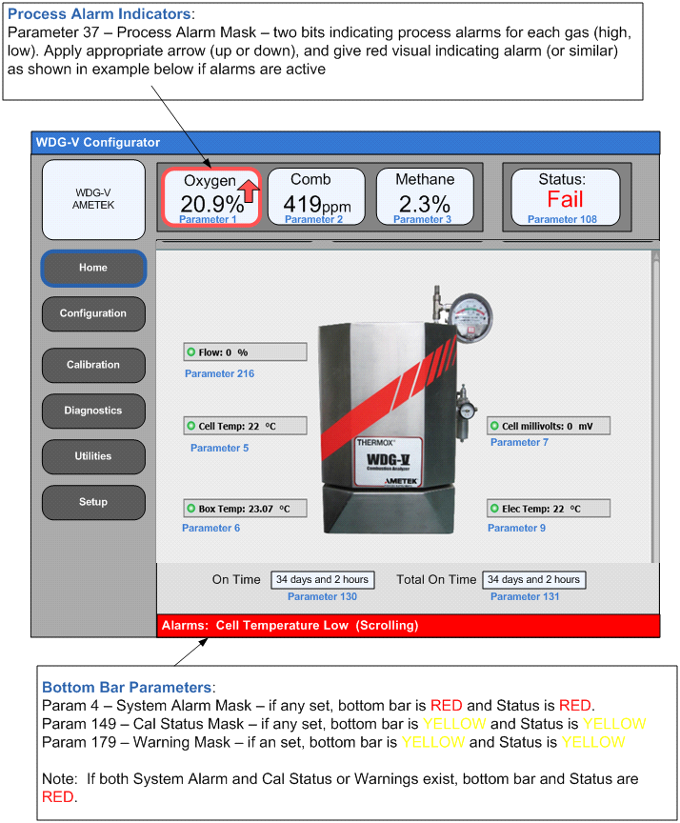

* Flow, Cell Temp, Box Temp, and Elec Temp green indicators should turn red if corresponding alarms are active.
* Cell Temp icon should be red if any of the following alarms are active:
* Cell TC Failure
* CJT Failure
* Cell Temp Control
* Cell Over Temp
* Cell Under Temp
* Cell Temp Rise Failure
* Cell TC Mismatch
* Box Temp Icon should be red if any of the following alarms are active:
* RTD Failure
* Box Over Temp
* Box Under Temp
* Box Temp Rise Failure
* Flow Icon should be red if any of the following alarms are active:
* Low Sample Flow
* Flow Sensor Failure
* Elec Temp Icon should be red if the following alarm is active
* CJT Failure
* Optionally, the Eventmask parameters (177, 178) can be used in lieu of parameters, 4, 149, and 179. The Eventmask parameters combine the System alarm Mask, Cal Status Mask, and Warning Masks into two params for ease of use….

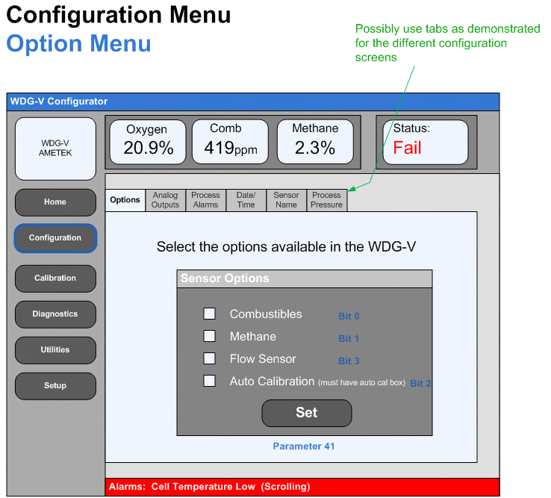

**Configuration Page: Option Menu**

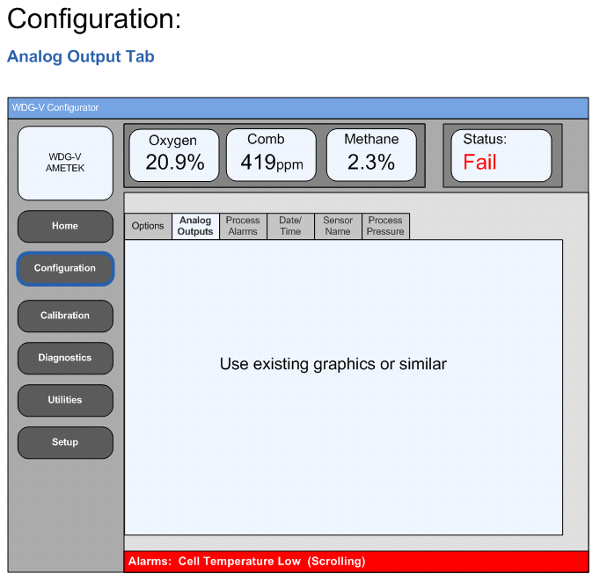

**Analog Output page**

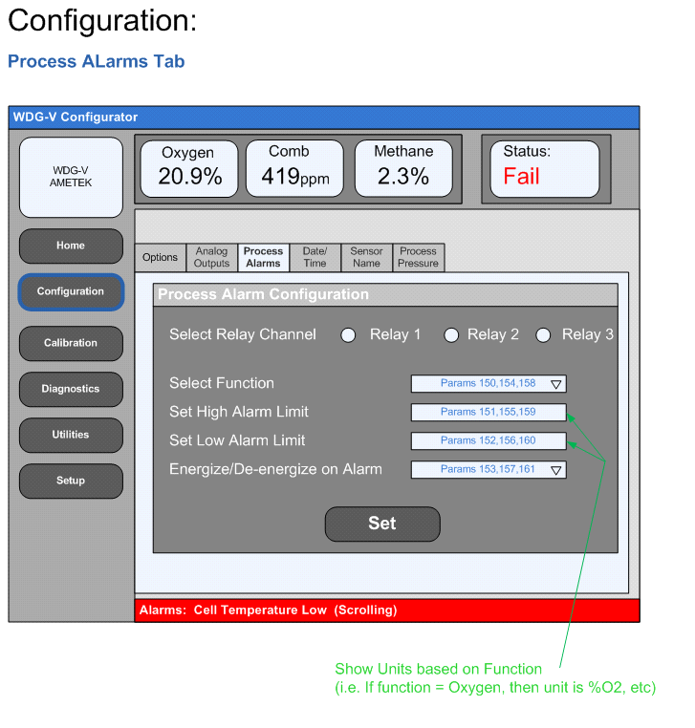

**Process Alarm Configuration**

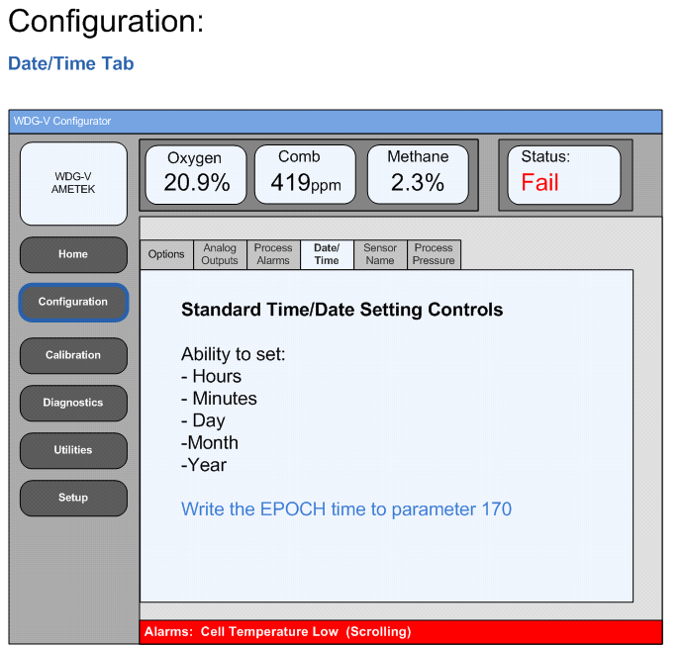

**Date Time configuration**

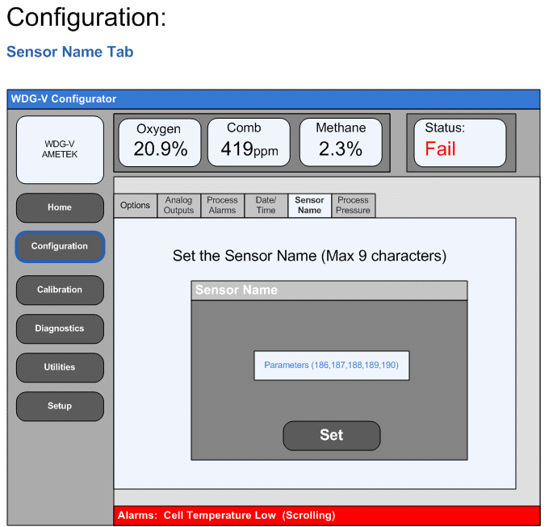

**Sensor name configuration**

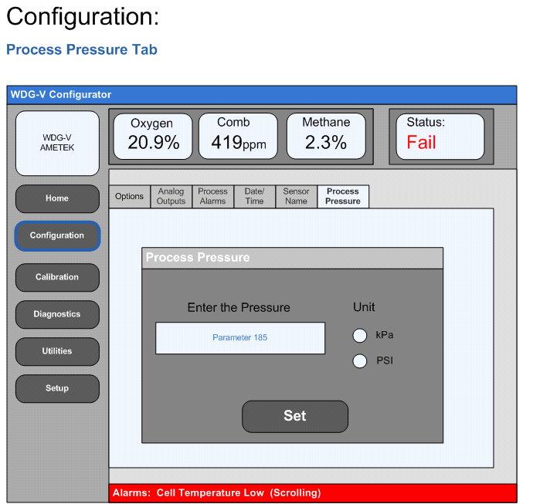

**Process Pressure**

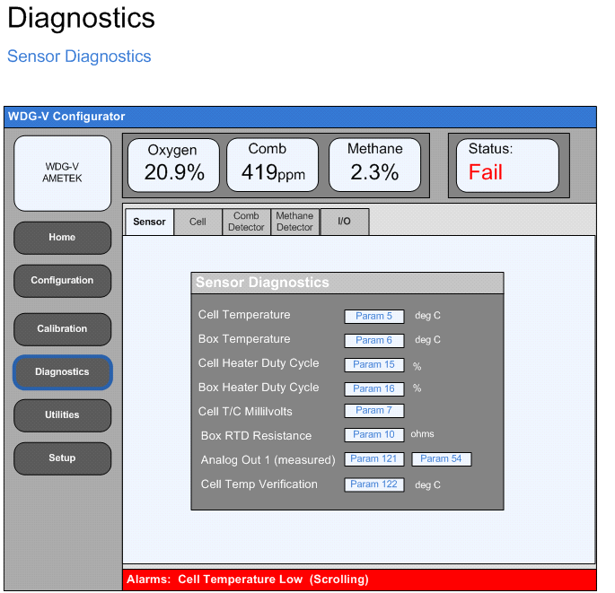

**Sensor Diagnostics**

Notes:

* Units can be integrated into the text box (preferably)
* All items are read only

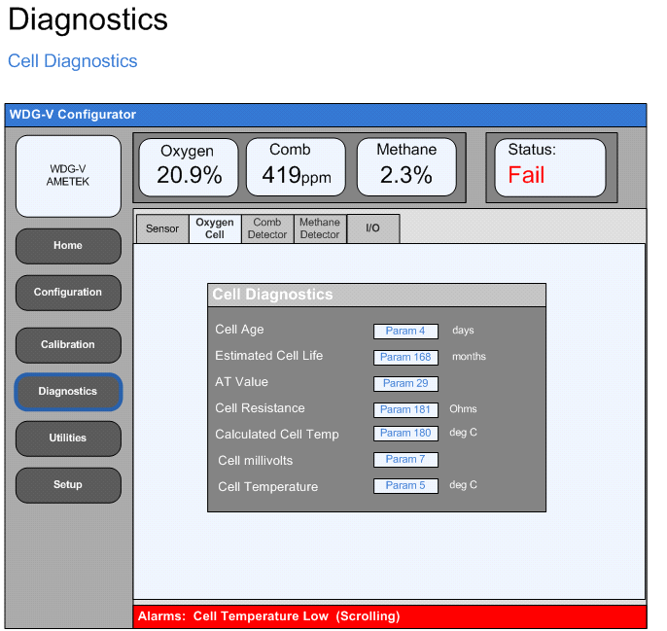

**Cell Diagnostics**

Notes:

* Units can be integrated into the text box (preferably)
* All items are read only
* Estimated Cell life is reported in days should be displayed in months. Divide value by 30 before displaying.

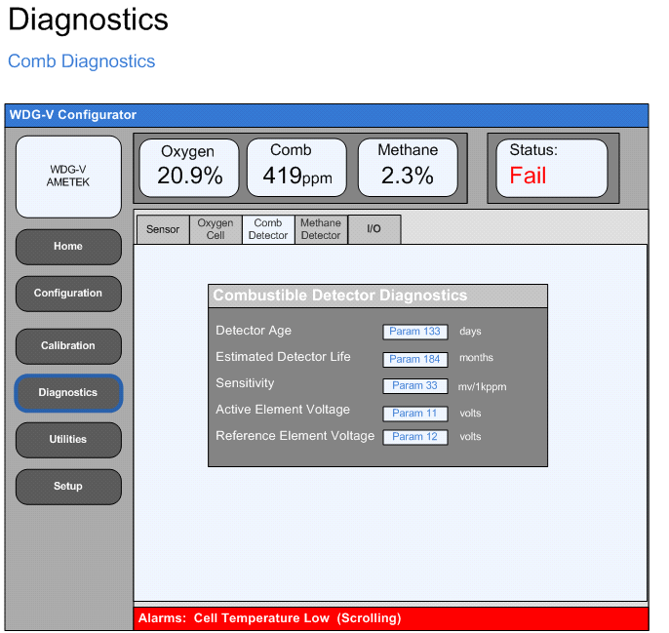

**Combustible detector diagnostics**

Notes:

* Units can be integrated into the text box (preferably)
* All items are read only
* Estimated Detector life is reported in days, should be displayed in months. Divide value by 30 before displaying.

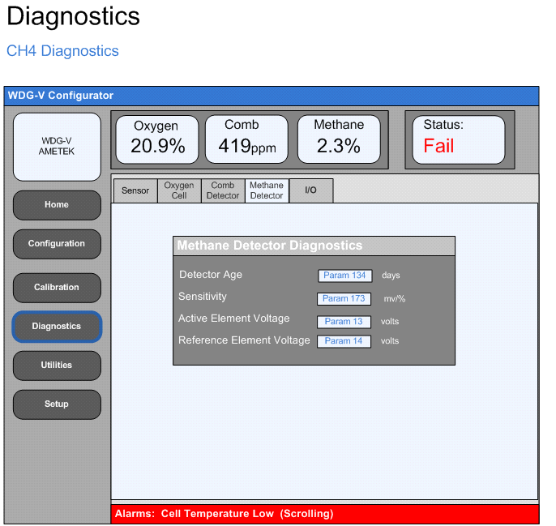

**Methane detector diagnostics**

Notes:

* Units can be integrated into the text box (preferably)
* All items are read only

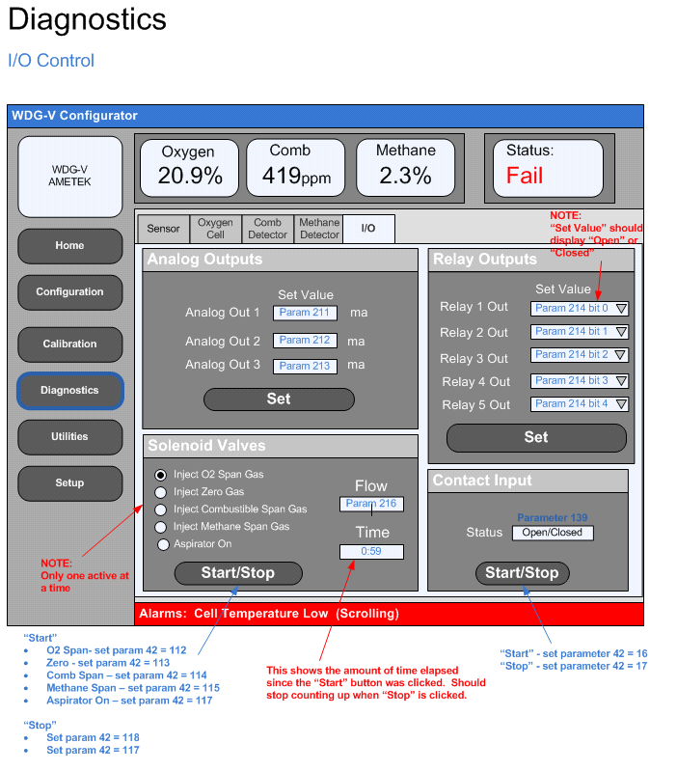

**I/O control**

# Appendix 3: Firmware upgrade flow chart

Start the download process by writing 0x7c to register 9001 (register not parameter)

Wait for 1 second.

Read 512 bytes from the file

Write the number of bytes read to the register 9001

EOF?

Yes

No

**[TISMO: Changes from Ametek-18 March 2014]**

**Proposed updates for the WDG-V Configurator.**

* Add the configurator software version number to the Utilities/About tab. Currently there is no version information about the configurator software.
* Remove the “*Back*” button from the “Set Gasses to Calibrate” screen as it is not functional or necessary. The button only appears after a calibration is completed and the “*OK*” button is pressed in the “*Cal Results*” screen.
* Add Flow Sensor Calibration capability. The flow sensor calibration is very similar to the O2, Comb, and methane calibrations. The calibration involves both a zero and span point. Example screens and flow are detailed below. Another tab can be added to the Calibration menu for this feature.

**First Screen:**

This screen commands the user to turn off the aspirator and calibration gas flow. No commands are sent to the sensor when the OK button is pressed. Before starting calibration the following conditions need to be checked.

* The parameter 36 (PARID_STATUSMASK) must be set to 0x20 to start calibration. If not pop up a message stating calibration is not possible.
* If Allow calibration (or) Flow sensor calibration is disabled, then this tab should be grayed out.

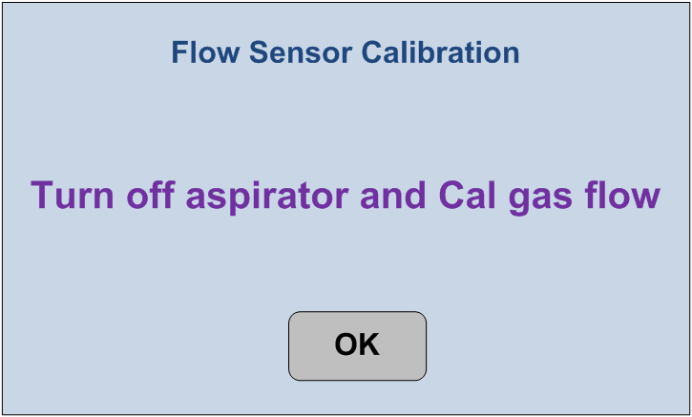

**Second Screen:**

The user is prompted to start the zero calibration. When the Start button is pressed, set **parameter 42** to value **12** and the timer should begin counting down to 0 in one second increments. Timer value need to be fetched from **parameter 40**.When the timer expires, the screen should automatically proceed to the third screen. Note that after the start button is pressed it should be “grayed” out. If the Abort button is pressed, prompt the user with “Are you sure you want to cancel the flow calibration” (yes/no). If yes, **parameter 42** should be set to value **9**. A temporary window (1-2seconds) indicating the "Flow calibration has been aborted" should be shown then the display should revert back to the first screen of the flow calibration.

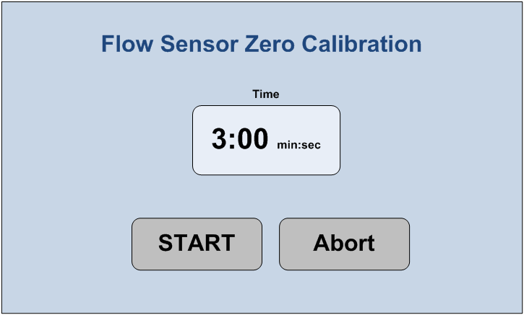

**Third Screen:**

This screen commands the user to apply calibration gas flow at 3 scfh. No commands are sent to the sensor when the OK button is pressed.

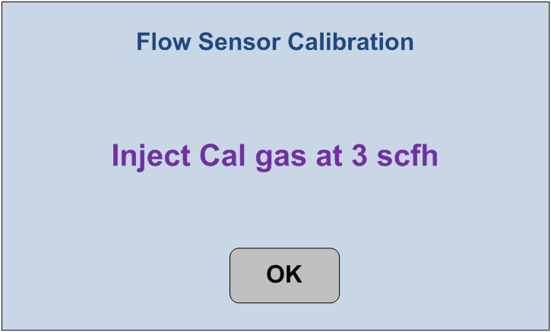

**Fourth Screen**

The user is prompted to start the Span calibration. When the Start button is pressed, set **parameter 42** to value **13** andthe timer should begin counting down to 0 in one second increments. Timer value need to be fetched from **parameter 40**.When the timer expires, the screen should automatically proceed to the results screen. Note that after the start button is pressed it should be “grayed” out. If the Abort button is pressed, prompt the user with “Are you sure you want to cancel the flow calibration” (yes/no). If yes, **parameter 42** should be set to value **9**. A temporary window (1-2seconds) indicating the "Flow calibration has been aborted" should be shown then the display should revert back to the first screen of the flow calibration.

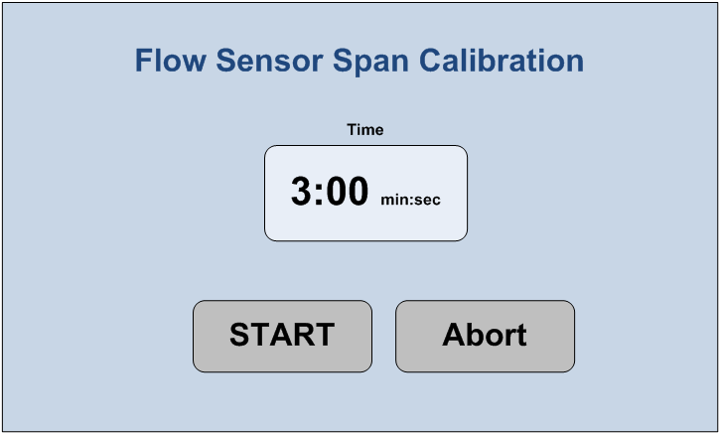

**Results Screen**

Show results status similar to cal results (i.e. Green Check or Red X) with recovery countdown timer displayed. Check the Last Flow Calibration Flag failed bit (bit 4) in the **CALSTATUS** parameter (param ID# 149, Modbus Reg # 270) . If set the cal failed, if clear the cal passed. An OK button should take the user back to the first flow cal screen. Apart from recovery timer and Cal result, Flow zero and Flow span values are displayed.

* Flow Zero value is fetched from **Parameter 126.**
* Flow Span value is fetched from **Parameter 215.**